FIT-EDGE: ADVANCED FITNESS INTELLIGENCE
A Project Based Learning Report Submitted in partial fulfilment of the requirements for the award of the degree

of

Bachelor of Technology
in The Department of Computer Science & Engineering
Course Title: DATABASE SYSTEMS ENGINEERING AND DISTRIBUTED BACKEND DEVELOPMENT
Course Code: 25CS1302E

Submitted by
2510030012 – K. Vishwas
2510030223 – G. Thanwish Reddy
2510030387 – A. Sachidananda Reddy
2510030154 – K. Narsimha Reddy
2510030294 – Praveen Reddy

Under the guidance of
Dr. Md. Rafeeq



Department of Computer Science & Engineering
Koneru Lakshmaiah Education Foundation, Aziz Nagar
Aziz Nagar – 500075
Academic Year 2026
Abstract
FIT-EDGE (Advanced Fitness Intelligence) is presented in the supplied project materials as a gym membership management and fitness portal intended to bring common gym operations into a single interface. The submitted website source archive contains a React and Vite application with pages and components for a dashboard, attendance, diet plans, equipment, members, membership plans, notifications, owner intelligence, payments, reports, trainer assignments and trainers. The visible interface uses role-oriented navigation for member, coach/trainer and owner access. Inspection of the supplied source archive supports a frontend implementation using React, Vite, Tailwind CSS, Lucide icons, Recharts and a QR-code React library. The application context stores operational demonstration records in browser localStorage. No separate Flask server, Python backend or PostgreSQL connection was identified in the supplied ZIP. The supplied project presentations describe a Flask/PostgreSQL architecture; this report preserves that proposed architecture as a review-stage claim but does not state that it is verified by the uploaded archive. The report follows the college template’s main sections—Introduction, Methodology, Experiments, Results, Conclusion and Future Work, and References—and organizes review evidence in the order of the supplied project materials. Screenshots are treated as visual evidence of displayed interfaces. Test outcomes are limited to the checks reported in the supplied results presentation and source-level observations; no unsupported performance figures are invented.
Keywords: gym membership management, React, Vite, localStorage, attendance, membership plans, trainer assignments, user interface, PBL.

Document Control
Item | Details
Project | FIT-EDGE: Advanced Fitness Intelligence
Course | Database Systems Engineering and Distributed Backend Development
Course Code | 25CS1302E
Department | Computer Science & Engineering
Faculty Guide | Dr. Md. Rafeeq
Academic Year | 2026

List of Figures
Figure 1. Member dashboard screenshot 35
Figure 2. Attendance access and gym occupancy screenshot 36
Figure 3. Login gateway screenshot 37
Figure 4. Membership plans screenshot 38
Figure 5. Trainer assignments screenshot 39
Figure 6. Members directory screenshot 40

List of Tables
Table 1. Requirement traceability matrix 17
Table 2. Payment scenarios and evidence needed 20
Table 3. Conceptual database relationships 23
Table 4. Functional test matrix 24
Table 5. Test environment record 25
Table 6. Literature review checklist 26
Table 7. Risk and mitigation register 28
Table 8. Questions for the project viva 29
Table 9. Source technology evidence 32
Table 10. Functional module inventory 33
Table 11. Source material traceability 34
Table 12. Implementation evidence boundaries 41

Table of Contents
1. INTRODUCTION 7
Background, problem statement, aim, objectives, scope and requirements 7–8
2. METHODOLOGY 9
Literature review, gap analysis, conceptual design and proposed method 9–12
Source-verified architecture and module analysis 11–12
3. EXPERIMENTS 13
Test approach, verification matrix and browser-persistence experiment 13–14
4. RESULTS 14
Reported findings, screenshot evidence, test matrix and analysis 14
5. CONCLUSION AND FUTURE WORK 15
SUPPLEMENTARY TECHNICAL DETAIL 17–29
APPENDICES — source inventory, glossary and evidence notes 30–41
REFERENCES 42

1. INTRODUCTION

Background and Context
Gym and fitness facilities coordinate member registration, subscription plans, attendance, trainer assignment, payment status, equipment and member communication. If these activities are handled in disconnected files or informal records, staff may need to search several sources to answer basic operational questions. The supplied PBL material identifies fragmentation, duplicate records and difficult retrieval as the problem context for FIT-EDGE.
FIT-EDGE is framed as a web-based portal that groups these activities into named modules. Its screenshots show a persistent navigation panel, summary cards, status labels and dedicated pages. The source archive contains React page components for the major modules. This provides evidence of a structured interface, but not proof that every operation is connected to a shared production database.

Problem Statement
The project problem is to make gym information easier to view and manage by organizing member, membership, attendance, trainer and payment workflows in one interface. The review presentations additionally propose relational storage to improve consistency. The source archive provided for inspection demonstrates browser-side state and localStorage rather than a verified relational database connection.
The report therefore distinguishes the user-interface objective from the database architecture described in the review presentations. The first can be assessed from the source and screenshots; the second remains unverified unless a separate backend repository or database evidence is supplied.

Aim and Objectives
Aim: design and present an organized digital portal for common gym management activities with role-oriented screens and clear navigation.
Objectives: (1) centralize navigation; (2) display member and trainer records; (3) present membership plans; (4) provide attendance access; (5) include diet-plan information; (6) provide payment and notification pages; (7) include equipment, reports and owner-oriented pages; (8) document storage and integration boundaries accurately.

Project Scope and Modules
The source archive contains Dashboard, Attendance, Diet Plan, Equipment, Members, Membership Plans, Notifications, Owner Intelligence, Payments, Reports, Trainer Assignments and Trainers pages. Reusable components include a login gateway, sidebar, navbar, notification center, QR-related modal and add-member/add-trainer modals.
The report does not claim physical biometric hardware, live payment processing, cloud deployment or production-grade authentication because those integrations are not established by the supplied source. QR-related UI is not equivalent to a tested scanner integration.

Stakeholders and Users
The principal stakeholders are gym owners/administrators, members, trainers/coaches, reception or operations staff, the student project team and the faculty supervisor. Each group needs a clear view of relevant information while avoiding access to unrelated or sensitive records.
The owner role is associated with high-level operations and reports; members are associated with plans, fitness and attendance; trainers are associated with roster and assignment information; operations staff need member lookup and attendance handling. These are intended usage patterns inferred from module names and screenshots, not evidence of a deployed organizational workflow.

PROBLEM IDENTIFICATION
The supplied project material describes separate or manual records for members, attendance, memberships and payments. The listed challenges include manual data entry, attendance tracking difficulty, missed membership details, harder payment monitoring and inconsistent or duplicate records.
The proposed response is a centralized web interface with organized modules for viewing and entering records. The visible interface follows this approach by bringing common gym activities into one place. For reliable use by several staff members, the final system should connect these screens to a shared backend and database. The team should confirm the final storage setup and describe it consistently throughout the report.

FUNCTIONAL REQUIREMENTS
FR-01 dashboard renders; FR-02 membership plans can be opened; FR-03 member directory displays records; FR-04 attendance page presents logs/status; FR-05 trainer assignments show member-trainer pairing; FR-06 diet plan page is available.
FR-07 payments page displays payment status; FR-08 notifications page displays alerts; FR-09 local changes persist in the same browser where localStorage is used; FR-10 owner intelligence and reports are reachable. These are testable requirements; their individual pass/fail state should be recorded after running the final build.

NON-FUNCTIONAL REQUIREMENTS
Usability requires readable labels and discoverable navigation. Consistency requires repeated interface patterns to behave similarly. Maintainability benefits from page modules and shared state. Privacy requires care with member data and screenshots. Reliability requires persistence and error-path tests. Security requires more than visual login labels.
These requirements provide a practical evaluation checklist. The screenshots support a consistent visual design, while security, accessibility, reliability and cross-device behavior require direct testing. No formal user study or security audit was supplied.

2. METHODOLOGY [1]

LITERATURE REVIEW METHOD
The supplied literature-review presentation lists Google Scholar, IEEE Xplore, ACM Digital Library, SpringerLink, ScienceDirect and official technical documentation as potential sources. Search themes include gym membership database normalization, ER models, attendance indexing, subscription transaction safety, relational versus document databases and role-based access control. [3]
The presentation contains a generic comparison matrix and explicitly says its Study A–E rows are placeholders, not claims about named published papers. This report therefore describes themes rather than inventing studies, author names, publication years or results.

COMPARATIVE THEMES
Member and plan management concerns structured member records and subscription status. Attendance concerns timestamped access logs and fast lookups. Billing concerns payment status and renewal consistency. Trainer allocation concerns member-trainer relationships. Normalization concerns repeated values; indexing concerns query speed; transactions concern coordinated updates; role-based access concerns permissions.
These themes are relevant to FIT-EDGE modules. They are database design considerations, not proof that the current frontend uses a normalized relational schema, SQL indexes or atomic database transactions.

GAP ANALYSIS
The review material identifies potential weaknesses in manual or weakly integrated systems: duplicate data, repeated searches, payment-renewal inconsistency, limited reporting and insufficient access controls. The proposed direction includes normalized schema design, constraints, indexes, transactions and integrated reports. [3]
In the supplied source archive, pages exist for reports, owner intelligence, payments, attendance and members. The archive uses localStorage for application records. The central unresolved gap is whether a shared backend exists to support multi-user consistency and relational integrity.

CONCEPTUAL ENTITIES
The review material proposes Members, Memberships, Payments, Attendance and Trainers as core entities, with related concepts for plans, member cards and trainer assignments. A normalized relational implementation could use primary keys and foreign keys to express these relationships. [3], [4]
This is a conceptual model based on the review material, rather than a database schema taken from the React interface. The design explains how members, memberships, payments, attendance and trainers could be connected through keys and relationships. Before describing it as the implemented database, the team should compare it with the final schema and include the relevant table definitions or migration files.

NORMALIZATION
First normal form encourages atomic values; second normal form addresses partial dependencies where composite keys are used; third normal form reduces transitive dependencies. In a gym domain, member contact information should not be repeated in every payment row, and plan definitions can be stored separately from individual memberships.
Normalization can reduce update anomalies in a relational database. It should be applied and tested in the actual schema. The frontend’s localStorage JSON data does not itself enforce relational normal forms.

INDEXING
The review proposes indexes on frequently searched fields such as member phone numbers, attendance timestamps and card identifiers. Indexes can improve selective queries, but they require storage and may add write overhead.
The value of an index should be demonstrated using actual query plans and representative data. Since no PostgreSQL schema or execution plan was supplied, indexing remains a design recommendation rather than a measured optimization.

TRANSACTION SAFETY
A payment and a membership renewal can be logically linked. A database transaction can ensure related changes are committed together or rolled back together. This prevents partial updates when a failure occurs between operations.
Frontend state updates are not equivalent to database transactions across users or devices. If the final implementation uses a server/database, transaction behavior should be tested and described using evidence from that backend.

PROPOSED METHOD
The supplied methodology describes a layered application using HTML/CSS/Jinja, Flask/Python, PostgreSQL and psycopg2. It lists requirement analysis, database setup, frontend development, backend development, testing/debugging and deployment as implementation steps. [1]
This sequence is preserved as the proposed methodology. The uploaded archive instead contains React/Vite source. The report treats the two descriptions separately rather than combining them into an unsupported architecture.

SOURCE INVENTORY
The package manifest declares React, React DOM, Vite, Tailwind CSS, Lucide React, Recharts and qrcode.react. The source tree contains an application shell, page components, reusable UI components, shared context and CSS files. [5]–[7], [9], [10]
The reviewed project folder contains the React/Vite application and its frontend modules. The Flask and PostgreSQL approach appears in the review-stage material, so the team should confirm whether a separate backend project is part of the final submission. If it is, include its source files and explain how the frontend connects to it. This will make the architecture description clear and consistent.

VERIFIED ARCHITECTURE
The source-supported architecture is: main.jsx starts the React application; App.jsx selects the active page; reusable components provide navigation and modals; page components render module interfaces; AppContext.jsx shares state; localStorage stores JSON records in the current browser profile. [5], [6]
This architecture is different from the review-stage flow Input → Flask → PostgreSQL → Output. Both should not be shown as one connected architecture unless the separate backend is verified.

APPLICATION STATE
AppContext.jsx initializes several state categories from localStorage when saved values are available and otherwise uses initial records. Effects write state back to localStorage. This pattern allows records to remain after refresh in the same browser profile, subject to the application’s logic and browser storage behavior. [8]
LocalStorage is origin- and browser-profile-specific. It does not automatically synchronize records between different computers or users. Clearing site data may remove locally stored records. These properties matter when evaluating a system intended for a gym with multiple staff members.

MODULES
The source contains page components for dashboard, attendance, diet plan, equipment, members, membership plans, notifications, owner intelligence, payments, reports, trainer assignments and trainers. This page-oriented structure gives each operational area a distinct UI module.
The presence of a page component confirms source-level inclusion, not complete end-to-end operation. Each module should be tested for rendering, navigation, form validation, state updates, error handling and persistence before claiming full functionality.

ROLE-ORIENTED UI
The login gateway includes Member, Coach and Owner options. Screenshots show member and trainer contexts. Role-oriented navigation can help users find relevant tasks.
The visible role selection does not by itself prove secure authentication or server-side authorization. Sensitive operations should be enforced by a trusted backend in a production deployment, and unauthorized-access tests should be documented.

ATTENDANCE
The attendance screenshot displays gym occupancy indicators, check-in/check-out statuses, a passcode-style entry field and an attendance directory. The source includes AttendancePage and QR-related components. [10]
These artefacts support the presence of attendance-related interface elements. They do not establish integration with a physical biometric reader, a turnstile or an external attendance device. Such integrations need device-level tests.

MEMBERSHIP AND PAYMENTS
The membership plans screenshot displays plan cards, prices and feature lists. The source includes payment-related UI and state functions that add or update payment records in the application context.
Payment labels such as UPI or verification should be interpreted as interface workflow unless a payment provider, transaction identifier and provider response can be verified. This report does not claim that money is transferred by the current source archive.

DIET AND FITNESS
The member dashboard screenshot shows a nutrition schedule, daily calorie target and macronutrient values. A Diet Plan page exists in the source archive.
The screenshot supports the display of diet-related information. It does not establish medical validation or individualized nutrition accuracy. Future work should ensure that any health-related recommendation is reviewed by qualified professionals and presented with appropriate limits.

OWNER INTELLIGENCE AND REPORTS
The source includes OwnerIntelligencePage and ReportsPage. These modules indicate an intended owner-oriented summary and reporting capability.
Their existence supports module-level inclusion. Any claim of real-time revenue analytics, database-backed aggregation or financial accuracy requires testing against known data and the actual persistence layer.

DEVELOPMENT PROCEDURE
A reproducible workflow is to inspect the package manifest, install dependencies, run the declared development script, exercise each module, record actual results and run the production build. The manifest declares dev, build, lint and preview scripts.
The supplied package manifest identifies the available development, build, lint and preview commands. Their successful execution in the preparation environment was not independently established for this report; therefore, no successful build or test run is claimed. Reproducibility requires documenting the environment, command output and any warnings or errors when those checks are performed.

3. EXPERIMENTS

REPORTED RESULTS [2]
The supplied results presentation reports checks for dashboard access, membership plans, memberships, trainers, navigation and database retrieval. It also states that four website screens were captured, six functional cases completed, zero visible screenshot errors, and no exact response-time benchmark was included. [2]
These results are reported in the supplied presentation. The project files reviewed for this report mainly show the React/Vite interface, so the database retrieval results should be checked against the final backend and its test records. During the final review, the team should record the exact steps used, the data retrieved and the observed outcome. This will help separate results already demonstrated from results that still need confirmation.
For example, opening a page and seeing a list confirms that the interface can display that view. To confirm database retrieval, the tester should also show where the records are stored, perform a query or related action, and compare the result with the expected records. This extra evidence makes the result easier for another person to repeat.

4. RESULTS

Results Overview
The member dashboard screenshot shows a profile card, membership identifier, fitness score, streak, QR pass action and nutrition schedule. The attendance screenshot shows current occupancy and attendance records. The login screenshot shows Member, Coach and Owner entry options.
The membership screenshot shows plan cards and prices. The trainer assignment screenshot shows member-trainer pairing and a roster. The member directory screenshot shows member cards, plans, status and coach details. These are interface observations, not proof of a connected production database.

Review Findings
The test matrix should record the action, expected result, actual result, status and evidence file. A screenshot proves that a page was displayed at a particular time; source inspection proves that a component exists; neither alone proves a backend transaction or persistence behavior.
The report therefore distinguishes “screenshot evidence available,” “source page exists,” and “test still to execute.” The team should update this matrix after running the exact final build rather than assigning PASS by assumption.

Functional Verification
Objective: check whether a sample record remains after refresh in the same browser. Procedure: open the app, change a non-sensitive demo record, refresh the page, and compare the result. Then repeat in another browser profile to test whether the change is shared.
Expected interpretation: persistence in the same profile supports localStorage behavior. A second browser not showing the change is consistent with local-only storage. The experiment should only be reported as completed after the team records actual observations.

Interface Evidence
The supplied results presentation states that exact response time was not measured. This report therefore provides no invented milliseconds, throughput, concurrent-user capacity or database query benchmark. A valid test must state the machine, browser, network, dataset, action sequence, tool and repetition count.
Possible metrics include initial page load, navigation-to-render time, lookup latency, local state update duration and multi-user behavior. A multi-user benchmark requires a shared backend and controlled test environment.

Analysis of Findings
The screenshots show consistent navigation, cards, status labels and high-contrast accent colors. These patterns can help scanning and module discovery. This is a visual inspection only; no formal user study was supplied.
Future usability tests should measure task completion and collect user feedback. Accessibility checks should include keyboard navigation, focus states, labels, contrast, screen-reader semantics and responsive behavior.

Limitations of the Results
The main risks are architecture mismatch, browser-local data, sample records, payment wording, security labels, QR/biometric wording and unmeasured performance. Each can create a gap between what the UI appears to do and what is verified end-to-end. Mitigation: verify architecture, test role and QR controls, label demo data, validate payments, and benchmark only under repeatable conditions.

5. CONCLUSION AND FUTURE WORK

Conclusion
FIT-EDGE presents a multi-module gym-management interface. The supplied React/Vite source has a page-oriented structure, reusable components and shared application context. The context uses localStorage for browser-side persistence of application records.
The PBL review materials describe a broader Flask/PostgreSQL design and report functional checks. The reviewed application files show the React/Vite frontend, and the connection between the two parts should be confirmed before submission. If the backend is maintained separately, the report should identify that repository and include suitable evidence of the connection. Keeping the architecture, implementation details and test results aligned will make the final explanation easier to follow.

Future Work — Technical Roadmap
Priority 0: resolve the architecture mismatch and verify login/role behavior. Priority 1: implement or verify shared storage, payment workflow and recovery behavior. Priority 2: perform performance, usability, accessibility, cross-browser and multi-device testing.
If centralized multi-user storage is required, connect a backend and database with documented schema and migrations. Add secure server-side authorization, input validation, transaction handling and audit records where appropriate.

REFERENCING APPROACH AND CITATION POLICY
The supplied literature presentation includes placeholder study rows. They are not treated as real publications. The reference list should include only sources actually consulted and verified. The project artefacts are cited as supplied PBL review materials. [1]–[4]
Technology references include the official React [5], Vite [6], Tailwind CSS [7], MDN localStorage [8], Recharts [9] and qrcode.react [10] documentation. The supplied project artefacts and presentations are listed separately in references [1]–[4].
References are included to show where the project information and technical descriptions came from. The team-supplied presentations support the project scope and the review-stage method, while official documentation supports descriptions of the tools used in the frontend. Before submission, check that every source listed here was actually consulted and that the citation numbers match the places where the sources are discussed.

SUPPLEMENTARY TECHNICAL DETAIL

DETAILED REQUIREMENTS TRACEABILITY
The following traceability matrix connects the needs identified in the PBL review materials to the modules visible in the supplied website source. A requirement describes intended behaviour; a screenshot or source file shows evidence of an interface; an executed test is needed to establish whether the behaviour works. These evidence types must not be treated as interchangeable.
Table 1. Requirement traceability matrix
Requirement | User need | Available evidence | Verification still needed
Member overview | Find member information | Members page and screenshot | Check search, status filters and edit actions
Membership plans | Compare subscription options | Membership Plans page and screenshot | Test selection and any resulting state change
Attendance | Review access events | Attendance page and screenshot | Test check-in/out and persistence
Trainer allocation | See member-trainer pairing | Trainer Assignments page and screenshot | Test creation, validation and reassignment
Diet plan | View nutrition information | Diet Plan page in source | Check page rendering and content labels
Payments | Review payment status | Payments page in source | Verify whether provider processing exists
Notifications | Review operational alerts | Notification page/component | Test creation, dismissal and persistence
Owner reports | Review operational summaries | Reports and Owner Intelligence pages | Compare calculations with known sample data
Persistence | Retain changes after refresh | localStorage use in AppContext | Perform controlled refresh test
Role separation | Show role-oriented entry | Login gateway screenshot/component | Test direct navigation and restricted actions

Interpretation: a module's presence in the source does not prove every function is complete. During final verification, record an actual result, date and tester for each action performed. Use NOT RUN for checks that have not been executed.

DETAILED MODULE ANALYSIS — DASHBOARD AND MEMBERS
The dashboard acts as the application’s orientation point. In a gym-management context, it can summarize member counts, membership status, attendance activity and tasks requiring attention. The supplied interface uses cards and a consistent dark visual theme to make information scannable. Any numbers shown in a demonstration should be treated as sample values unless they can be traced to a verified data source.

Dashboard verification
A useful check is to compare a displayed summary with the records used by the application. If a card shows the number of active members, the team should define what active means, count records meeting that rule, and compare the result with the displayed value. This report does not state a numerical accuracy result because no controlled comparison was supplied.

Members directory
A member directory helps staff locate a person and inspect relevant information such as membership status or assigned trainer. Useful behaviour includes readable labels, stable identifiers, predictable status indicators and clear empty states. The supplied screenshot supports that the interface displays a directory with member and plan-related information, but it does not establish that records synchronize across different computers.
Recommended manual checks include searching for a known sample member, searching for a value that does not exist, checking blank-field handling, and confirming whether an edit is reflected in the directory and any related summary. If an action is unavailable, record it as a limitation instead of implying that it is implemented.

DETAILED MODULE ANALYSIS — ATTENDANCE AND QR
Attendance records represent access events, not just member profiles. A robust design should distinguish check-in from check-out, record timestamps and define how incomplete sessions are handled. The supplied screenshot shows an attendance-oriented page with occupancy indicators and records. The correctness of occupancy calculations must be verified against the sample records.

Suggested attendance cases
Test a member with no attendance event, a member who has checked in, and a member with a completed check-in/check-out pair. Record what the interface shows before and after each action. Also check whether duplicate check-ins are accepted and whether invalid sequences are prevented.

QR-code boundary
The source package includes a QR-related React library and a scanner-modal component. This supports the existence of QR-oriented frontend code. It does not establish that a physical scanner, secure token service or biometric device is connected. QR codes are machine-readable symbols; biometric verification is a different category of identity check.
If QR check-in is part of the demonstration, test it with the exact browser and device that will be used. Record whether the camera opens, whether a code is detected, what information is encoded, how invalid codes are handled and whether attendance state changes. Do not place real credentials or sensitive member data in a public demonstration QR code.

DETAILED MODULE ANALYSIS — MEMBERSHIPS AND PAYMENTS
Membership plans define the available subscription options. A plan card commonly communicates a name, duration, price and included features. The supplied screenshot shows plan cards and feature text. Prices and durations should remain consistent wherever they appear, and plan descriptions should not promise services that are not actually offered.

Plan definition versus member subscription
A reusable plan definition and a member’s subscription are separate concepts in a relational design. The plan describes an offering, such as its name, duration, price and included features. The subscription records which member selected the plan, when it starts and ends, and whether it is active or expired. This separation is part of the conceptual database design in the review material; the final database structure should be checked before claiming that these tables are implemented.

Payment evidence boundary
A payment page may show a history, pending status, verification status or payment instructions. Displaying a UPI identifier or a payment button does not prove that the application contacts a payment processor, receives trusted confirmation or reconciles a transaction with a membership renewal.
In a production system, confirmation should rely on a trusted provider response or verified server-side workflow, not solely on a client-side status toggle. Name a payment gateway only if its integration is present and tested. Until then, describe the observed feature as payment-related UI or a demonstration status workflow.
Table 2. Payment scenarios and evidence needed
Scenario | Expected safe behaviour | Evidence to collect
Plan selected | Selected plan is clear | Screenshot/state before and after
Payment pending | Pending status is distinguishable | UI record or screenshot
Payment failed | Membership is not falsely marked paid | Controlled test or documented limitation
Duplicate action | Avoid duplicate payment records where applicable | Repeat-action test
Provider success | Status reflects verified result | Provider test-mode evidence, if integrated

DETAILED MODULE ANALYSIS — TRAINERS AND DIET PLANS
Trainer records identify coaching staff, while trainer assignments represent relationships between members and trainers over time. Separating these concepts makes it possible to update a trainer profile without rewriting every assignment. The supplied screenshot shows an assignment interface with member/trainer selection and a roster.

Trainer assignment checks
Check whether a valid member and trainer can be selected, whether empty selections are rejected, whether the resulting pairing appears in the roster, and how reassignment is represented. If multiple assignments are allowed, the intended rule should be documented. Do not invent a business rule that the application does not implement.

Diet and fitness information
A diet-plan page can present a meal schedule or general nutrition information. It should be described as information displayed by the application unless there is evidence of a validated personalized recommendation engine. Nutrition requirements vary by individual; a prototype example should not be described as medical or dietetic advice.
If personalization is a future goal, define the inputs, recommendation rules, source of nutritional values and validation process. Any health-related data should be handled with appropriate privacy controls. For the current project, the supported claim is that a diet-plan module exists in the source and nutrition-related information appears in the supplied member-dashboard screenshot.

DETAILED MODULE ANALYSIS — EQUIPMENT, REPORTS AND NOTIFICATIONS
An equipment module can support an inventory of gym assets, identifiers and maintenance status. A useful extension would distinguish available, in-use, damaged and under-maintenance equipment. The source archive includes an equipment page, but its exact operations should be verified by exercising the interface. The report should not claim sensor integration or automatic maintenance alerts without evidence.

Reports and owner intelligence
Reports and owner-oriented insights can summarize membership, attendance, payments or trainer activity. Summary values are useful only when calculation rules are clear and the underlying data source is trustworthy. For example, the definition of an active membership should specify whether a status field, an end date or both determine activity.
A practical verification method is to create a small known set of sample records, calculate the expected summary manually and compare it with the page output. The team should note the sample data and formula. No performance or business-impact claims should be added without checks.

Notifications
Notifications can draw attention to membership expiry, pending payment or a new assignment. A clear notification should communicate what happened, what it concerns and what action is required. Whether notices are generated automatically, persisted across sessions or sent by email/SMS needs separate verification; a notice visible in the browser does not prove an external message was delivered.

CONCEPTUAL DATABASE DESIGN — RELATIONSHIPS AND CONSTRAINTS
This section expands the relational design proposed in the PBL review material. It is a conceptual model for discussion, not a claim that these tables currently exist in the supplied React source archive.
Table 3. Conceptual database relationships
Relationship | Conceptual cardinality | Design implication
Member—Membership | One member may have multiple membership periods | Membership references member_id
Plan—Membership | One plan may be used by many memberships | Membership references plan_id
Membership—Payment | One membership may have multiple payment events | Payment references membership/invoice
Member—Attendance | One member may have many events | Attendance stores member_id and timestamps
Trainer—Assignment | One trainer may have many assignments | Assignment references trainer_id
Member—Assignment | One member may have assignments over time | Assignment tracks dates and status
User—Role | Account has defined role/permissions | Authorization must be enforced securely

Keys and integrity
A primary key provides a stable identifier for each row. A foreign key expresses a relationship and can prevent references to nonexistent records. For example, a membership should not refer to a plan that does not exist. A frontend dropdown improves usability but does not replace database validation.

Uniqueness, checks and transactions
A relational implementation may need unique account identifiers, checks for non-negative prices and payments, and not-null constraints for essential fields. Exact constraints depend on business rules. A transaction groups related database operations into a unit that succeeds or fails together. This matters when payment confirmation and membership renewal must remain consistent. A browser localStorage update is not equivalent to a multi-user database transaction.

TEST DESIGN — POSITIVE, NEGATIVE AND EDGE CASES
Testing should cover normal use, invalid input and boundary conditions. A test case should record its identifier, preconditions, steps, expected result, observed result and status. The following cases are proposed for the team to execute; they are not presented as completed tests.
Table 4. Functional test matrix
ID | Area | Scenario | Expected behaviour
T-01 | Navigation | Open each visible module | Correct page content appears
T-02 | Members | Search for known member | Matching member appears
T-03 | Members | Search nonexistent value | No-results state appears
T-04 | Form | Submit required field empty | Validation blocks invalid submission
T-05 | Attendance | Check in valid sample member | Attendance state changes visibly
T-06 | Attendance | Attempt duplicate check-in | Defined duplicate rule is enforced
T-07 | Membership | Select a plan | Selected plan is identifiable
T-08 | Payments | Simulate failed/pending payment | Membership is not falsely shown as paid
T-09 | Trainer | Assign valid trainer | Assignment appears in roster
T-10 | Trainer | Submit without selection | Validation or clear error appears
T-11 | Persistence | Refresh after edit | Expected local state is restored if saved
T-12 | Isolation | Open separate browser profile | Local-only data is not assumed to sync
T-13 | Role access | Open restricted area directly | Sensitive action is blocked if authorization exists
T-14 | Responsive UI | Resize to narrow viewport | Content remains readable
T-15 | Accessibility | Navigate by keyboard | Focus is visible and controls are reachable

Use PASS only when observed behaviour matches the expected result in a repeatable test. Use FAIL when it does not, NOT RUN when no test was performed, and NOT APPLICABLE only when the case genuinely does not apply. Explain failures rather than replacing them with a general statement that the system works.

TEST ENVIRONMENT AND REPRODUCIBILITY
The package manifest declares npm scripts for development, build, lint and preview. To make a test reproducible, the team should record the operating system, Node.js version, npm version, browser version, source archive version and exact command used. This report does not claim that these commands passed in the student's environment during preparation.
Table 5. Test environment record
Field | Record before submission
Operating system | Windows version on demonstration laptop
Node.js version | Record node --version
npm version | Record npm --version
Browser | Name and version
Source version | ZIP filename/date
Start command | Exact command used
Build command | Record result if run
Test date/time | Actual time tests were performed
Tester | Team member
Warnings/errors | Concise, non-sensitive output

Reproducibility steps

1. Use a clean copy of the supplied source folder.
2. Install dependencies using the project's lockfile if present.
3. Run the declared development command and record errors.
4. Open the site in the target browser and check principal modules.
5. Perform planned test cases using non-sensitive sample data.
6. Capture evidence only after the relevant behaviour is observed.
7. Run the production build if required and record its actual result.
8. Retain the resulting test notes as supporting evidence for the report.

RESEARCH METHOD — SEARCH, SELECTION AND LIMITATIONS
The supplied literature-review presentation lists academic search platforms and topic phrases relevant to gym-management databases. The available materials do not provide complete details for all studies in the comparison matrix, so this report does not invent papers or treat placeholder rows as published research. A full academic review would document the retrieved papers, selection criteria and relevance of each verified source.

Suggested selection criteria
Prefer sources that directly discuss relational database design, membership/subscription management, attendance tracking, transaction consistency, access control or comparable information systems. Peer-reviewed papers, standards and official technical documentation are preferable for technical claims. Avoid treating search-result snippets as if they were full studies.
Table 6. Literature review checklist
Dimension | Question for each real source
Problem | What specific issue does the source examine?
Method | Case study, experiment, design analysis or survey?
Context | What setting or dataset supports its claims?
Result | What result is actually reported?
Limitations | What does the source not establish?
Relevance | Which project requirement or decision does it inform?

The supplied literature-review slides contain generic matrix placeholders rather than complete bibliographic details for every row. These placeholders are not publications and are not cited as real studies. Accordingly, the literature discussion is limited to themes visible in the supplied materials; a full academic review would require identifiable, verified publications.

DEPLOYMENT, MAINTENANCE AND OPERATIONS
The supplied package manifest supports a Vite-based development workflow. A production deployment requires a build output, a hosting environment and verification that asset paths and routing behave correctly there. The existence of a dist folder alone does not establish a successful current deployment.

Maintenance
A maintainable application should document setup steps, keep dependencies reviewed, remove unused packages and avoid committing secrets. Shared UI elements should be reused where appropriate. Changes to data structures should be accompanied by tests so that older browser-stored records do not break the application.

Backup and recovery
Browser localStorage is not a managed backup system. Users may clear browser data, switch profiles or use another computer and find that records are unavailable. A production multi-user system should define central storage, backups, restoration tests and responsibility for recovery.

Operational rules
A future operational version should document who creates member accounts, who can update plans, how payment disputes are handled, how attendance errors are corrected, and how former members' records are retained or deleted. Clear operational rules help prevent inconsistent records even when the interface is well designed.

RISK REGISTER AND MITIGATION DETAIL
The risk register links technical uncertainties to practical mitigation. A risk should be marked resolved only when the team has evidence that the mitigation works; adding a reassuring label to the interface is not sufficient evidence.
Table 7. Risk and mitigation register
Risk | Why it matters | Mitigation | Evidence
Architecture mismatch | Report and ZIP differ | Confirm final codebase and update diagram | Source inventory
Local-only persistence | Different devices may not share records | Add shared backend if required | Cross-device test
Unauthorized access | Personal data could be exposed | Verify authentication and authorization | Role-access test
Payment misrepresentation | Financial trust is affected | Use precise wording; verify provider integration | Test-mode evidence
Unverified test claims | Academic credibility risk | Mark unrun tests honestly | Completed test matrix
Sample data confusion | Demo values may be mistaken as real | Label illustrative records | Screenshot audit
Reference metadata may be incomplete | Literature credibility risk | Use checked bibliographic records | Citation audit
Accessibility gaps | Some users may struggle to operate UI | Keyboard, contrast and screen-reader checks | Issue log

Risk review
Review this list before the demonstration and before final submission. The highest-priority item is resolving the difference between the review-stage Flask/PostgreSQL description and the React/Vite source archive. That decision affects the architecture diagram, implementation claims, testing chapter and answers to faculty questions.

FINAL PRESENTATION PREPARATION
Use the following sequence to explain the project clearly while remaining consistent with the report and evidence.
1. Introduce the problem and intended users.
2. Explain the review-stage database proposal and the architecture verified in the supplied source.
3. Open the role-oriented login gateway without overstating security.
4. Show the member dashboard and identify sample/demo values.
5. Show membership plans, member directory, trainer assignments and attendance.
6. Explain the boundaries of payment and QR-related functionality.
7. Show the source organization and explain React context and localStorage.
8. Present the test matrix and distinguish executed tests from tests not run.
9. Conclude with limitations and realistic next steps.

Likely evaluation questions
Table 8. Questions for the project viva
Question | Evidence-based answer direction
Why this project? | Explain the operational problem and integrated interface goal.
What technology is used? | React/Vite frontend; localStorage use appears in source.
Is PostgreSQL connected? | Not evidenced by the supplied ZIP; review slides describe it.
Is payment processing live? | State only what has been tested; UI labels are not proof.
Does data sync between laptops? | Not automatically if only browser localStorage is used.
Main limitation? | Resolve architecture mismatch and verify persistence/security.
Next step? | Confirm architecture and test key workflows.

APPENDIX — SOURCE FILE INVENTORY
package.json identifies dependencies and scripts; vite.config.js configures Vite; main.jsx is the entry point; App.jsx is the application shell; AppContext.jsx contains shared state and localStorage operations; page components correspond to the listed modules.
Reusable components include LoginGateway, Navbar, Sidebar, NotificationCenter, QRScannerModal, AuthModal, AddMemberModal and AddTrainerModal. These components help keep common interface elements in one place and make the page structure easier to maintain. Their presence in the project folder shows how the interface is organized, while each workflow still needs to be tested separately before it can be described as fully working.
The application shell connects the main page area with shared navigation and state. Page components keep each topic, such as members or attendance, separate from the others. This organization makes it easier to locate code when a change is needed. When describing the implementation, it is useful to name the file or component that supports the claim rather than relying only on a screenshot.

APPENDIX — GLOSSARY
API: Application Programming Interface. CRUD: Create, Read, Update, Delete. ER model: Entity–Relationship model. FK: foreign key. PBL: Project Based Learning. PostgreSQL: relational database described in the review presentations. React: JavaScript library used by the supplied frontend.
localStorage: browser key-value storage. RBAC: Role-Based Access Control. SQL: Structured Query Language. UI: User Interface. Vite: frontend development and build tool. Jinja: template engine named in the review-stage architecture.
In this project, an API would allow the frontend and backend to exchange information through defined requests. CRUD describes the four basic actions performed on records: creating, reading, updating and deleting them. An entity represents a type of information, such as a member or payment, while a relationship explains how two entities are connected. These terms are useful when discussing the proposed database design.

SOURCE TECHNOLOGY EVIDENCE
Table 9. Source technology evidence
Evidence in archive | Interpretation
package.json lists react and react-dom | React frontend
package.json lists vite and scripts | Vite build/dev tooling
tailwindcss and @tailwindcss/vite | Styling setup
lucide-react | Icon components
recharts | Charting library dependency
qrcode.react | QR rendering dependency
AppContext.jsx uses localStorage | Browser-side persistence
No Python app or PostgreSQL connector identified | Backend not evidenced in this ZIP

FUNCTIONAL MODULE INVENTORY
Table 10. Functional module inventory
Module | Purpose represented by interface | Evidence boundary
Dashboard | Summary and navigation | Source and screenshot
Attendance | Attendance logs and check-in UI | Source and screenshot
Membership Plans | Plan cards and payment-oriented UI | Source and screenshot
Diet Plan | Nutrition plan page | Source page and dashboard screenshot
Notifications | Alert list | Source page
Trainer Assignments | Member-trainer pairing | Source and screenshot
Members | Directory and status | Source and screenshot
Trainers | Trainer records | Source page
Equipment | Asset records | Source page
Payments | Payment status UI | Provider integration unverified
Owner Intelligence | Owner-oriented analytics | Source page
Reports | Report view | Source page

REVIEW ORDER TRACEABILITY
Table 11. Source material traceability
Source material | Main focus | Where it is used
Proposed Methodology & Implementation | Project approach, tools, architecture and workflow | Methodology and source inventory
Literature Review & Gap Analysis | Literature themes, system gaps and database concepts | Methodology and conceptual database design
Results & Analysis | Screenshots and reported functional checks | Experiments and results
Gym Membership DBMS PBL Presentation | Project scope and database proposal | Introduction and conceptual database design

SCREENSHOT EXPLANATION — MEMBER DASHBOARD
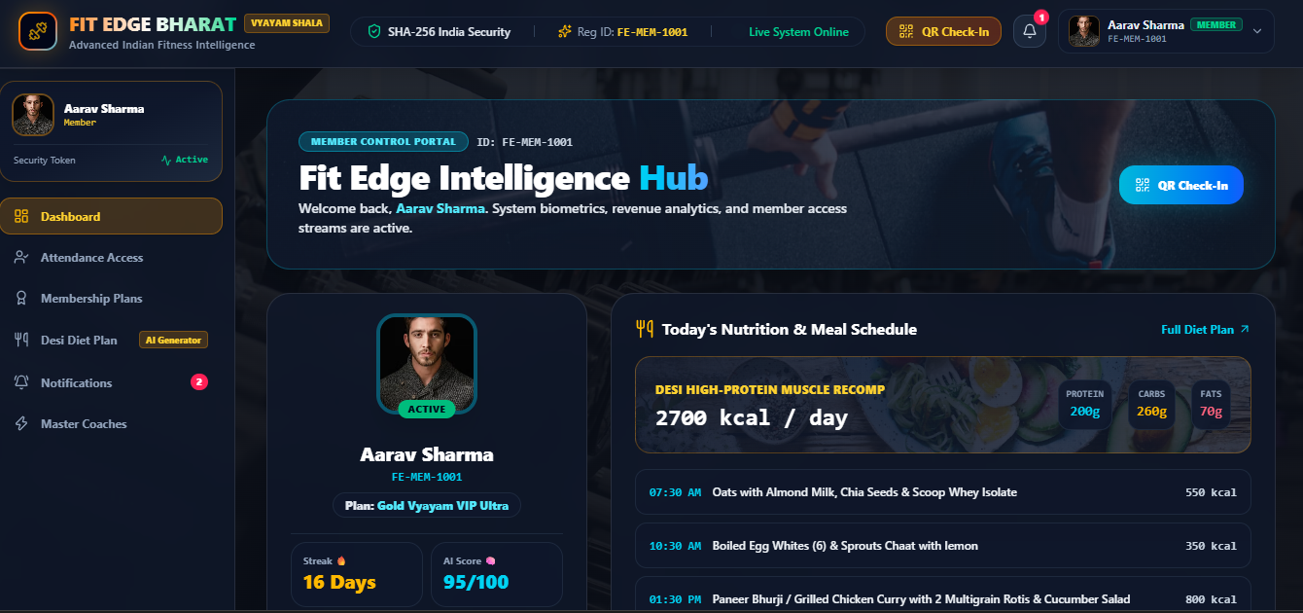
Figure 1. Member dashboard showing profile, fitness summary, membership and nutrition schedule.
What it shows: The dashboard brings together the member profile, fitness summary, membership information and nutrition schedule on one screen. This helps the member quickly review key information. The screenshot shows the interface layout; it does not verify the accuracy of health or nutrition recommendations.
A presenter can explain the dashboard by pointing out the profile area first, then the membership details and fitness summary, and finally the nutrition schedule. The layout is intended to reduce the need to open several separate pages for a quick overview. The values should be explained as sample information unless the team has checked them against the final data source.

SCREENSHOT EXPLANATION — ATTENDANCE
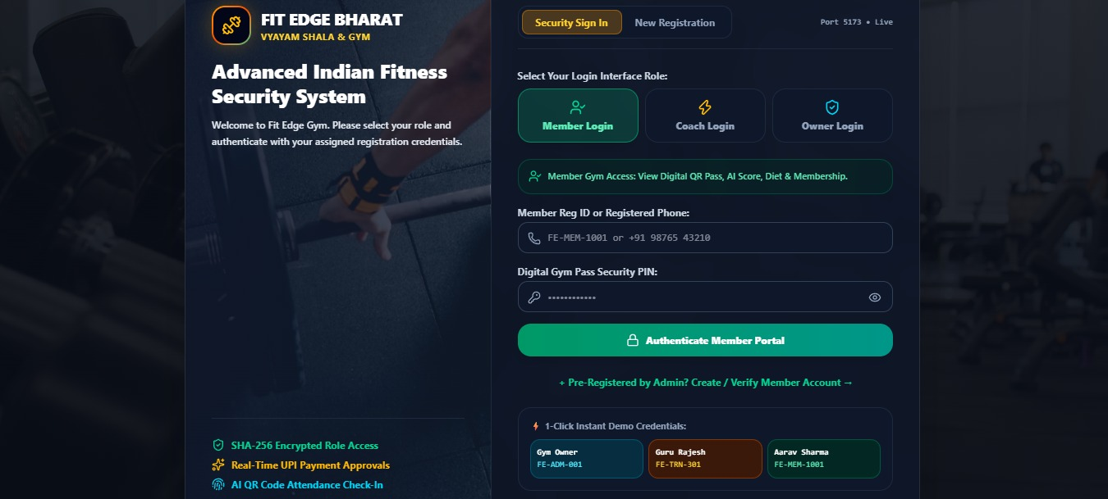
Figure 2. Attendance access and gym occupancy page.
What it shows: The attendance page presents gym occupancy information, check-in/check-out status and attendance records, along with an entry control. These elements illustrate how staff could review attendance activity. Actual QR scanning or biometric-device integration would need to be demonstrated separately.
During a demonstration, explain what each status means and how an attendance entry is expected to change after check-in or check-out. The team should also clarify whether the entry control is a working feature in the current build or only a visual element. This avoids confusing the displayed interface with a confirmed connection to scanning or access-control hardware.

SCREENSHOT EXPLANATION — LOGIN GATEWAY
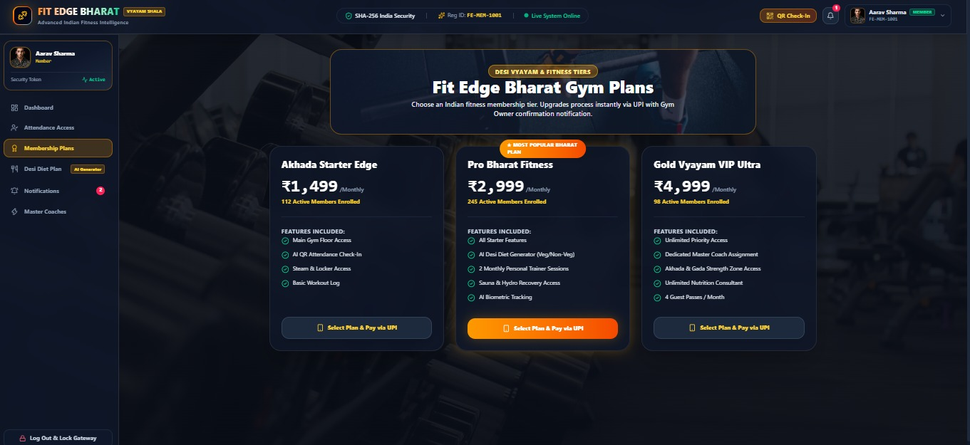
Figure 3. Login gateway showing Member, Coach and Owner choices.
What it shows: The login gateway offers separate entry choices for Member, Coach and Owner. This communicates the intended user categories and provides a starting point for role-specific navigation. The screenshot alone does not demonstrate that credentials are securely verified or that server-side permissions are enforced.
The three choices make the intended user groups easy to understand. In a complete system, each role would see only the pages and actions needed for its work. The login screen communicates that idea, but secure role separation must also be enforced by the authentication and authorization logic behind the interface.

SCREENSHOT EXPLANATION — MEMBERSHIP PLANS
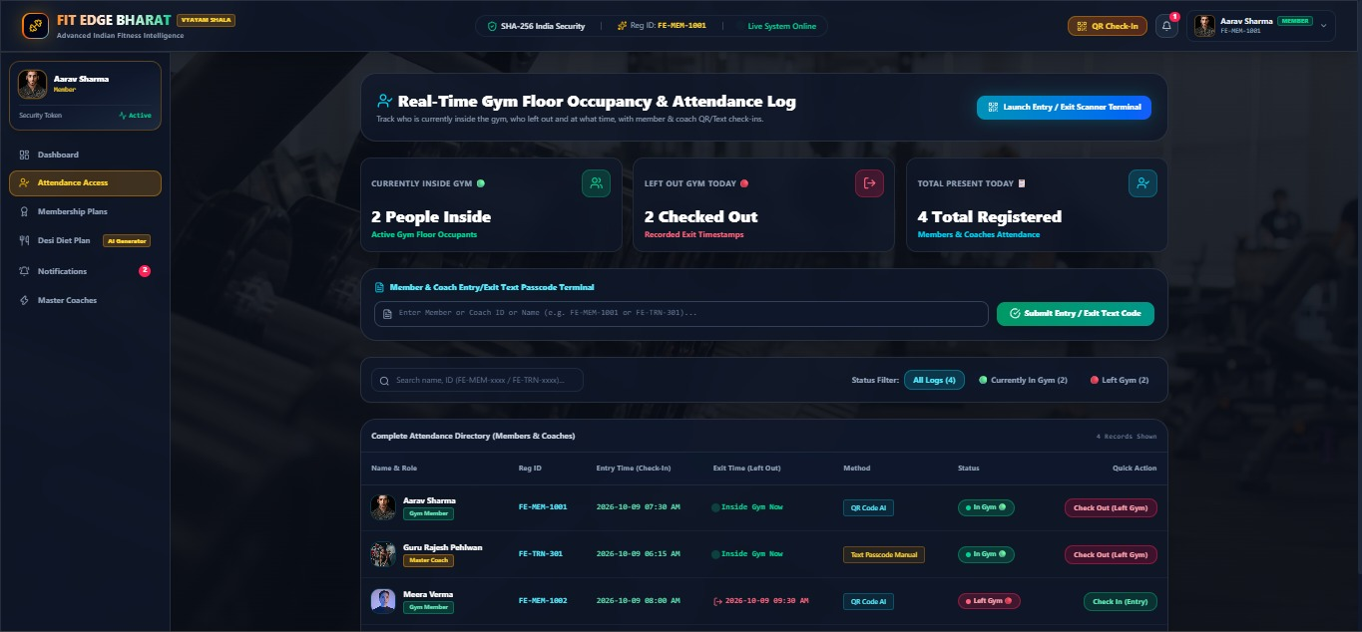
Figure 4. Membership plan cards and feature lists.
What it shows: The membership-plans page displays available plan options as cards, including prices and feature lists. This allows a user to compare the displayed plans. The screenshot demonstrates plan presentation, not a completed payment or a verified payment-provider connection.
When presenting this screen, compare the plan names, prices and listed benefits one by one. Explain that a plan describes what the gym offers, while a member subscription records which plan a person has selected. If the user continues to a payment step, describe only the behaviour that has been tested in the current version.

SCREENSHOT EXPLANATION — TRAINER ASSIGNMENTS
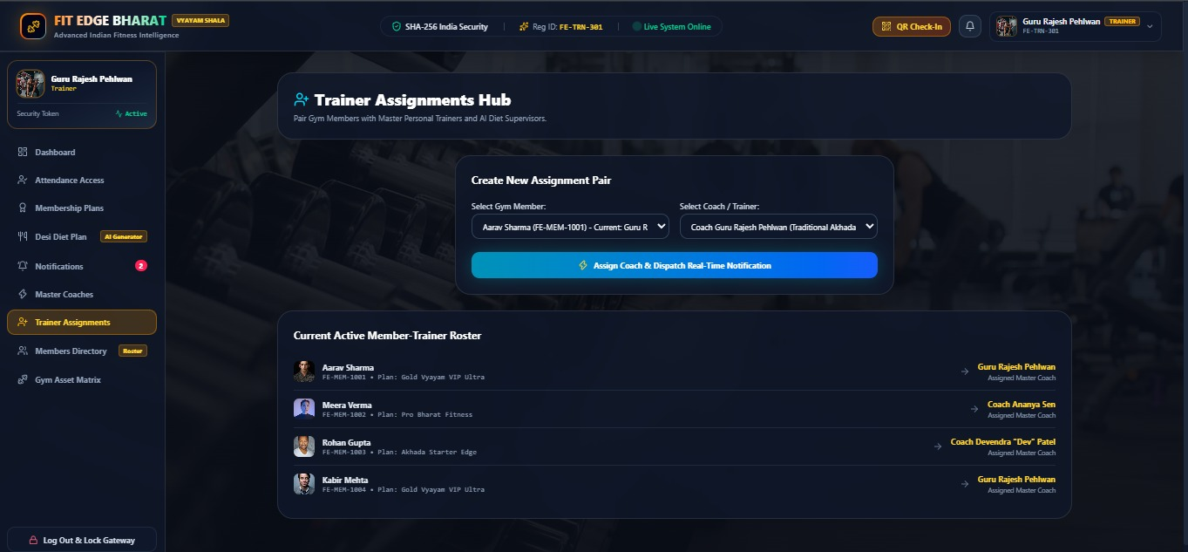
Figure 5. Trainer assignment interface and active roster.
What it shows: The trainer-assignment page presents controls for associating members with trainers and a roster of assignments. It illustrates how staff could review or manage coaching relationships. The screenshot alone does not confirm that assignment changes persist across users or devices.
The roster gives staff a quick way to review which members are associated with which trainers. A useful demonstration is to select a member and a trainer, submit the assignment if that action is available, and then check whether the roster changes. The result should be recorded after testing rather than assumed from the presence of the controls.

SCREENSHOT EXPLANATION — MEMBERS DIRECTORY
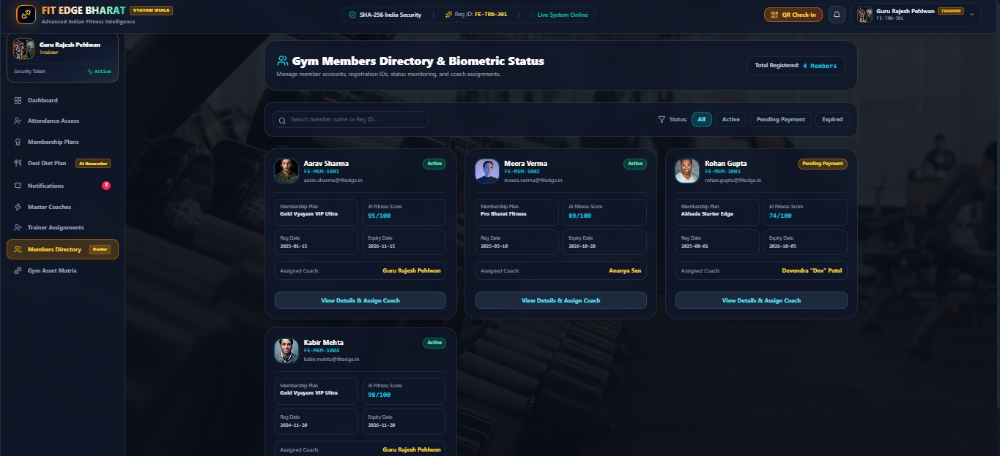
Figure 6. Members directory with plan and status details.
What it shows: The members directory organizes member entries and displays related details such as membership plan, status and coach information. This helps staff locate and review member information. Any names or values visible in the image should be treated as demonstration data unless their source and permission for use are confirmed.
For a clear explanation, point out how the directory groups member details and makes membership status easier to scan. A staff member should be able to identify the correct record without confusing it with another member. Search, filtering and editing behaviour should be described only after those actions have been checked in the running application.

FINAL EVIDENCE BOUNDARIES
Table 12. Implementation evidence boundaries
Claim area | Supported now? | What is needed for stronger claim
React/Vite frontend | Yes, source manifest and files | No further proof for stack identification
Browser localStorage | Yes, source code uses it | Repeatable refresh test for observed persistence
Flask backend | Confirm in final implementation | Backend source, connection setup and test logs
PostgreSQL connection | Confirm in final implementation | Schema, query or connection evidence with secrets removed
Live UPI payment | Not established | Payment provider test evidence
Biometric attendance | Not established | Hardware integration and test evidence
Exact performance | No benchmark supplied | Repeatable benchmark results

REFERENCES
[1] “FIT-EDGE: Proposed Methodology & Implementation,” team-supplied methodology presentation, project review document supplied by the team, 2026.
[2] “FIT-EDGE: Results & Analysis,” team-supplied results presentation, project review presentation supplied by the team, 2026.
[3] “Gym Membership Management System: Literature Review, Gap Analysis & Relational Database Design,” supplied project presentation, 2026.
[4] “Gym Membership DBMS PBL Presentation,” supplied project presentation, 2026.
[5] React Documentation. https://react.dev/ (accessed 9 October 2026).
[6] Vite Documentation. https://vite.dev/guide/ (accessed 9 October 2026).
[7] Tailwind CSS Documentation. https://tailwindcss.com/docs (accessed 9 October 2026).
[8] MDN Web Docs, “Window: localStorage property.” https://developer.mozilla.org/en-US/docs/Web/API/Window/localStorage (accessed 9 October 2026).
[9] Recharts Documentation. https://recharts.org/ (accessed 9 October 2026).
[10] qrcode.react package documentation. https://www.npmjs.com/package/qrcode.react (accessed 9 October 2026).

